Rugby – the conversion kick
Mathematical Investigation Task
Setting the Scene
After scoring a try, in a game of Rugby, a team can attempt to increase their score by taking a conversion kick. This is done when a player goes back, perpendicular to the goal line, from the point where the try was scored, and takes a kick for goal.
The question is, how far should they choose to go back? Can mathematics help them decide?
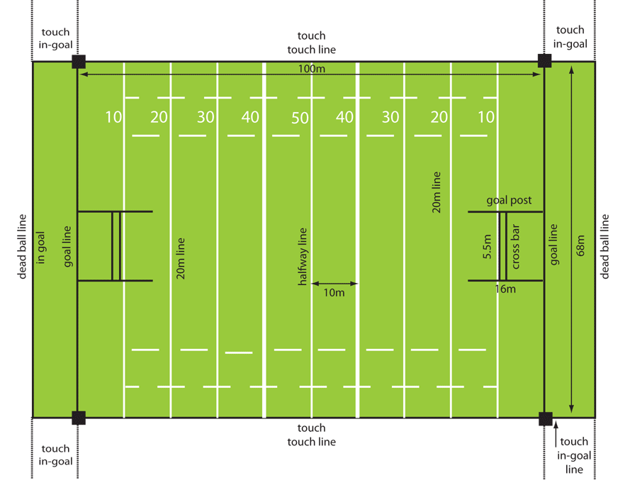
Initial Question
Based on the diagram (right) of a rugby pitch
  - Imagine a try is scored 20 metres to the left of the left-hand goal post.
  - Imagine the kicker goes back 5 metres perpendicularly from the point on the goal line where the try was scored.
What is the ‘angle of view’, the visible gap between the goal posts,
from that position?
Optimising the conversion kick
You will be assigned a distance that your try is scored from the nearest goal post.
You are to consider a range of kicking positions to determine the kicking position that maximises the
‘angle of view’ between the goal posts from that position.
The methods used should be selected with consideration of precision and efficiency
Generalising results
By collecting results relating to other try scoring distances and the corresponding optimal kicking positions, come up with some general advice that could help a rugby kicker make their high-stakes decisions in the heat of the contest.
Reasonableness and limitations
Is it reasonable to believe that your results help a rugby player select the position from which to take their next conversion kick? What limitations are there on your results?
Task completion
Complete these tasks and present your work as a free-standing piece of mathematics. Link together your work to create a purposeful whole. You work should be readable without reference to this task sheet.

